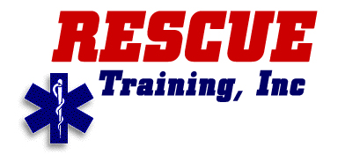

9-A Mall Terrace

P.O. Box 3853

Savannah, GA 31414

Phone : (912) 692-8911

Fax: (912) 692-1338

Toll free (877) 692-8911

www.rescue1.com

ATP/SOCM BRIDGE COURSE
Rescue Training Inc offers a Paramedic Prep course to Military Paramedics that have completed the ATP or SOCM program and desire National Registry certification:
Pre-requisites for the course:

- Current EMT-B card (National Registry/State)
- Current BCLS
- Copy of ATP Training
- Copy of SOCMSSC (If ATP course is greater than 2 years)

Course Information

- The intent of this course is to prepare the military paramedic to take the NR Paramedic CAT/Practical exam. Three-week course limited to 12 students.

Cost of the course:

- $1500 Total (includes NR testing fees)

- $500 non-refundable deposit to secure slot in course

Course Duration

- Three (3) Weeks

- FY 2012 Courses are scheduled once per quarter.

Reference Point of Contact:

Msgt Charles Halcome
(410) 328-7706
University of Maryland Shock/Trauma

